PART A: Speaking
1) Do you know any famous couples?
2) What do you know about their lives?

SUPER COUPLES
PART B: Read the text and answer the questions after each section.
Marie and Pierre Curie
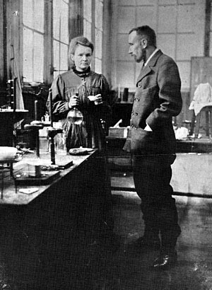 | 1) When Marie Sklodowska was 24, she left Poland and moved to Paris. While she was studying at the Sorbonne, she met physicist Pierre Curie. She was planning to return to Poland after her studies, but the two scientists fell in love and got married. While they were raising their daughters, they were also doing research on radioactivity. In 1903, the couple won the Nobel Prize in physics. Then, in 1906, a horse-drawn carriage hit and killed Pierre while he was walking.
Marie suffered from her loss for a while. After Marie recovered from the shock, she continued their work. In 1911, she received her second Nobel Prize.

1. Which of the following is TRUE about Marie and Pierre Curie?
a) They returned to Poland after they met.
b) They won two Nobel Prizes for their work.
c) They met when she was a student at the Sorbonne.
d) They took a break from work to raise their children.

2. In paragraph 1, find a word which means:
a. go back ___________________________
b. get well ___________________________

3. In paragraph 1, the word ‘they’ refers to ___________________________

Gloria and Emilio Estefan
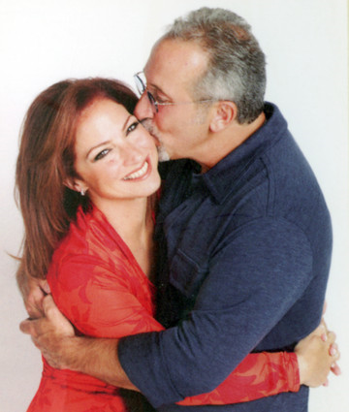 | 2) CONGA! In 1985, millions of people were listening to this hit song. It made singer Gloria Estefan and bandleader Emilio Estefan international stars. Gloria was born in Cuba and she was only 16 months old when she and her family moved to the USA. By that time, she was already showing her musical talent. She met Emilio when she was 17. Soon after, she joined his group. The couple married a few years later. They were enjoying their success in the music business when
Gloria broke her back in a traffic accident in 1990. She recovered and went on to win many awards for her Spanish and English songs.

4. Which of the following is FALSE?
a) Gloria had a talent for music even when she was a baby.
b) Gloria and Emilio became famous with the song, Conga.
c) Gloria’s continued to be successful after her accident.
d) Gloria moved the States at the age of 16 with her family.

5. In paragraph 2, what do these words refers to?
a. It ___________________________
b. his ___________________________
c. They ___________________________

6. In paragraph 2, find a word which means ‘a natural ability to do something well’ __________

Ekaterina Gordeeva and Sergei Grinkov
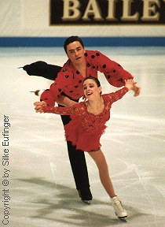 | 3) She was only 11 and he was only 15 when their coaches brought them together as skating partners. Off the ice, Sergei wasn’t paying much attention to “Katia”. However, that changed in 1988 when the pair won their first Olympic gold medal for the former Soviet Union. World-famous skaters Ekaterina Gordeeva and Sergei Grinkov thrilled their fans when they married two years later. A baby girl and another Olympic gold medal followed. Their lives seemed perfect. Then, one day Sergei
collapsed while they were practising. He died an hour later. Today Gordeeva is remarried and has a new skating partner.

7. According to paragraph 3, Ekatarina ____.
a) fell in love with Sergei when they met
b) stopped her skating career after Sergei died
c) had a baby after winning a second gold medal
d) married again after the death of Sergei

8. In paragraph 3, what do these words refers to?
a. them ___________________________
b. they ___________________________

9. The word ‘thrill’ is closest in meaning to ____.
a) invite b) understand c) decide d) excite

10. The word ‘seem’ is closest in meaning to ____.
a) perform b) appear c) find d) hope

PART C: Work in pairs. Look at the couple below and create their life story using past tenses. Write minimum 100 words.
Imagine:
- Who are they?
- What are their jobs? Are they famous or not?
- How did they meet?
- Did they always have positive experiences?

____________________________________________________________________________________________________________________________________________________________________________________________________________________________________________________________________________________________________

___________________________________________  ___________________________________________  ___________________________________________  ___________________________________________  ___________________________________________  ___________________________________________ | 
____________________________________________________________________________________________________________________________________________________________________________________________________________________________________________________________________________________________________

